Tuebingen pharmacy students in Malawi
Wanda Siewert 29 October 2018
https://www.pharmazeutische-zeitung.de/tuebinger-pharmaziestudenten-in-malawi/
As part of the course "Pharmacy in Global Health" at the University of Tübingen, five pharmaceutical students from Tübingen had the opportunity to participate in an exchange with the Pharmacy Department of the College of Medicine of the University of Malawi in Blantyre. Three of us first visited a five-day workshop on traditional herbal medicines in Malawi. Subsequently, we accompanied and supported Malawi pharmacy students for four weeks in collecting data on their Bachelor work. Each of us worked with a different group of Malawian students on different topics.
Production of simple local drug prescriptions from vegetable raw materials.

Malaria medicines and self-medication
One group visited 24 Health Centres (comparable to an outpatient practice) to document the stock of malaria medicines and antihypertensive drugs and derive their availability and consumption. Here it was noted that while malaria medicines were abundant through the work of international aid programmes, antihypertensives were found only in small numbers and in limited varieties, mostly only hydrochlorothiazide and one or two packs of atenolol.
Another group conducted a survey of the population of the city of Blantyre for self-medication with malaria drugs. In fact, many patients knew very well about the disease and also that it can be treated with the standard drug lumefantrine arthemeter. Only about 15 percent said they use self-medication for malaria. Most people who suspected malaria went to health facilities, where a quick test can be performed for the diagnosis.
Asthma and diabetes therapy
Asthma patients in the Queen Elizabeth Central Hospital in Blantyre and the Kamuzu Central Hospital in the capital Lilongwe were interviewed by another group about their knowledge of the disease and its treatment. In Malawi, the treatment of choice is salbutamol. This is regarded by the population surprisingly critically. Some believe that the inhalations are addictive and would not help in an emergency. Also, the training of patients to use the inhaler is not optimal.
The fourth group analyzed patient records for medication errors in diabetic insulin therapy at Queen Elizabeth Central Hospital and Kamuzu Central Hospital. Normally, in cases of severe diabetes, the blood sugar should be checked every two hours. Unfortunately, due to lack of staff, this is often not done, which has an effect on insulin therapy. In addition, insulin is only given in the hospital. Type 1 diabetics can take home insulin, but most of the time it is difficult to store because most people do not have a refrigerator and cannot measure blood sugar at home.
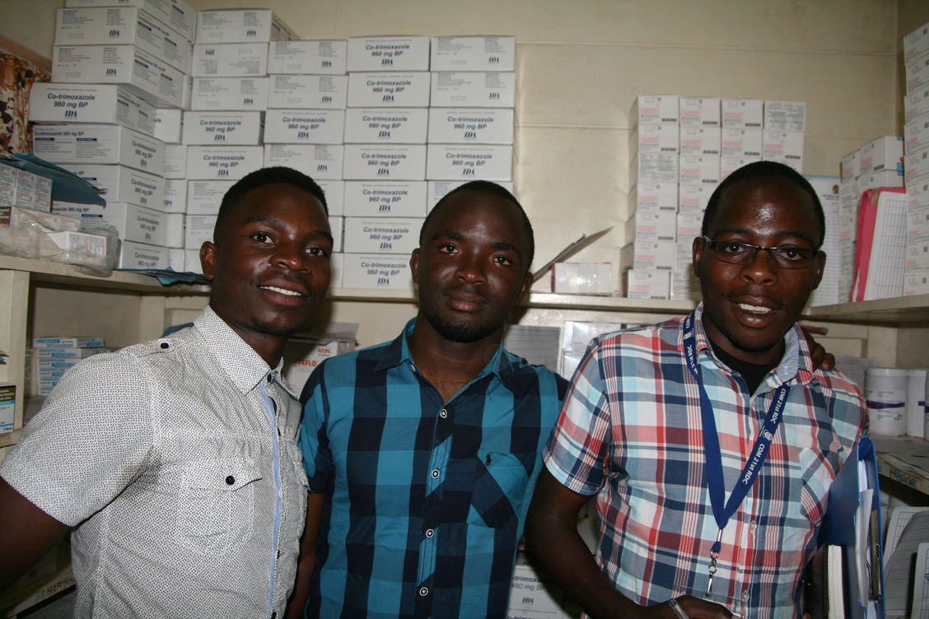
Three Malawian pharmacy students taking stock of malaria medicines and antihypertensives in a health centre.

Antibiotic use
My group analyzed patient records at Queen Elizabeth Central Hospital. Our goal was to document the use of ceftriaxone and meropenem to determine if the application was in compliance with national treatment guidelines. It was noticeable that ceftriaxone was wrongly used as a first-choice drug. Almost every patient suspected of having any infection first receives ceftriaxone. The dosage at least corresponded to the national guidelines. Laboratory tests for more accurate pathogen determination are often requested but not performed or not quickly enough. Therefore, a specific antibiotic therapy is often not possible. There is a great danger here of promoting the development of resistance.
Travel and culture
During our stay we visited the country on the weekends. In Malawi there are different ethnic groups. In a museum in Mua Mission, we got to know the traditions of the three largest groups (Chewa, Ngoni and Yao). Traditional medicine still plays a big role. Nevertheless, it is a secret topic and hardly anyone talks about their application. This often complicates the therapy with Western medicine in hospitals, since interactions can occur.

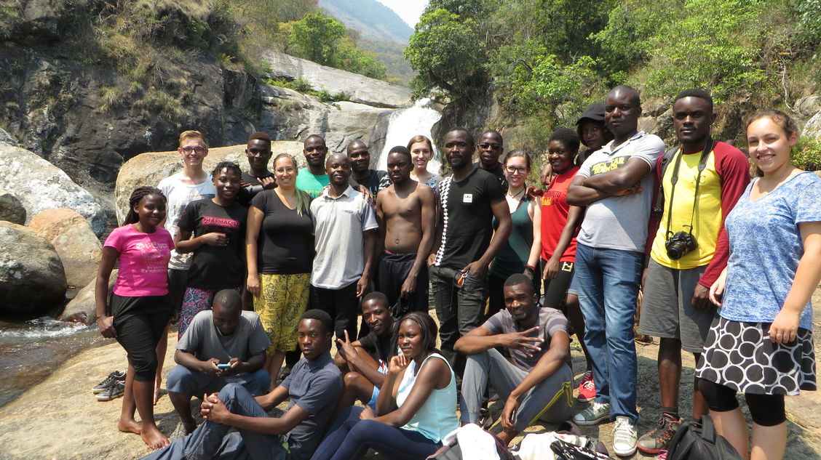
Tuebingen and Malawi pharmacy students on a trip to the Mulanje massif in Malawi

