COLLEGE OF MEDICINE

MEDIC TO MEDIC HURST ESSAY

HOW COOPERATION BETWEEN AFRICAN COUNTRIES CAN IMPROVE THE SITUATION OF LIMITED RESOURCES SPENT ON HEALTHCARE

WRITTEN BY: STUART JERE

INTRODUCTION

Access to quality health care in Africa still continues to be a big challenge as most of the countries have very limited health care resources. Studies have shown that 40% of the medical equipment used in sub-Sahara Africa is out of service, 80% is donated by the donors from developed countries and 70-90% of this donated equipment is never operationalized(2). In Rwanda there is only 5,430 medical equipment in 45 district hospitals of which approximately 67% are functional, in Malawi there is approximately 20 000 medical equipment in 22 district hospitals plus 87 health centres of which only 85% is functional(10). Most of this non-functional equipment is as a result of difficulties in acquiring spare parts, and lack of skilled technical staff (2).

To make matters worse most of the countries in Africa lack funding to purchase Morden equipment and pharmaceuticals. In addition there is shortage of health workers due to brain drain because many workers leave their home countries to search for greener pastures in developed countries. There is also a very high prevalence of diseases such as HIV aids (66% of the global prevalence), tuberculosis (accounts for 500 000 deaths annually) and malaria (60% of global burden) which hinders development thereby increasing poverty rate. Rural urban migration causing urbanisation has also worsen the situation as it has brought about health hazards including substandard housing, air pollution, insufficient or contaminated drinking water, poor sanitation and sewage systems. This has completely increased incidence of water and air borne infectious diseases posing a threat on the limited resources (3).

EXAMPLES OF HEALTHCARE COOPERATION BETWEEN AFRICA COUNTRIES

Some countries in Africa are better off than others for example south Africa which as of 2014 the public sector had 12 Magnetic Resonance Imaging machines, 51 computerised topography scanners, 30 radiotherapy machines, 9 telecobalt unit, 21 linear accelerators and 32 mammography (5) where as in Malawi the situation was worse, there was no any of the above mentioned equipment except 2 computerised topography scanners (6). This is therefore a clear indication that cooperation among these countries can help minimise problems because severe cases can be referred to the countries where medical equipment is available.

One of the examples of the cooperation is the southern Africa development community (SADC) comprising of South Africa, Malawi, Lesotho, Swaziland, Namibia, Zambia, Zimbabwe, Mozambique, Seychelles, Tanzania, Mauritius, Congo, Botswana and Angola. Some of the objectives of this treaty includes; cooperation in the procurement and maintenance of the medical equipment, sharing of information regarding the use of particular equipment, establishment of appropriate clinical guidelines for referral within the nations and production and procurement of affordable drugs and promoting coordination of laboratory services in the region(4).

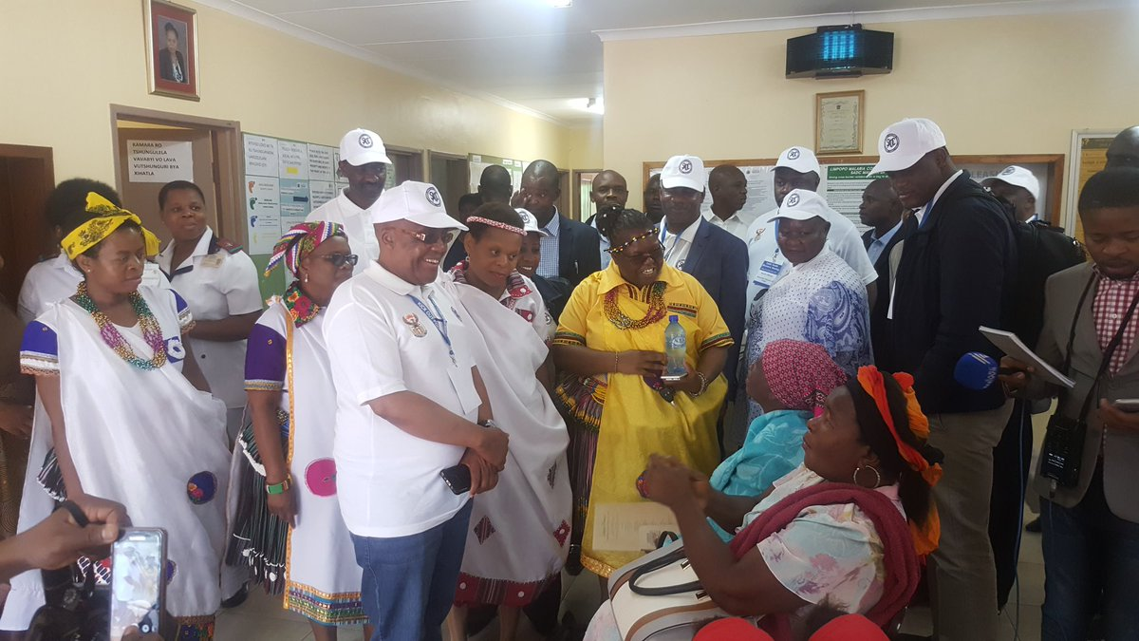

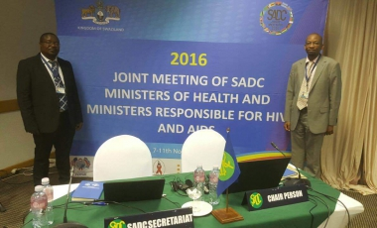

SADC health ministers commemorating malaria day at Thomo village,Giyani limpompo
Joint meeting of SADC ministers of health and ministers responsible for HIV and AIDs in 2016

Another cooperation is the West Africa health organisations (WAHO). The organisation was formed in 1987 comprising of 15 country members of Economic Community of West African States (ECOWAS). These countries include; Benin, Burkina Faso, Cape Verde, Cote D’Ivoire, Gambia, Ghana, Guinea, Guinea-Bissau, Liberia, Mali, Niger, Nigeria, Senegal, Sierra Leone and Togo. The objective of the organisation includes attainment of the highest possible standard and protection of health of the peoples in the region through the harmonization of the policies of the Members, pooling of resources and cooperation with one another and with others for a collective and strategic combat against the health problems of the region (1).

In East Africa there is EAC (East Africa community) which consists of six countries in the Africa great lakes region including Burundi, Kenya, Rwanda, South Sudan, Tanzania, and Uganda. This organisation was founded in 1967 and is currently being chaired by John Magufuli the president of Tanzania. One the roles of this treaty is to undertake joint action towards control of the non-communicable diseases and control pandemics and epidemics of communicable and vector borne diseases which might affect the community. It is also responsible for facilitating community mass immunisation campaigns. All these roles will help to reduce pressure on the limited resources since there will be reduced spreading of the diseases (7).

STRENGTHS OF COOPERATION
So many achievement have been realised following cooperation between African countries in as far as health sector is concerned. East Africa community has resulted into strong regional cooperation and integration in the health sector through harmonisation of the national policies and amongst the policies are pharmaceutical policies, food security and disease surveillance (7). This has helped in ensuring that drug prices are lowered and spreading of diseases is reduced. Cooperation has also helped to control the epidemics affecting several neighbouring countries at once. In addition to this, cooperation has helped to improve the quality of pharmaceutical products for example in West Africa health organisation (11).

WEAKNESS OF COOPERATION

Many objectives of this cooperation have not been achieved due to various factors. There is lack of harmonisation and coordination such that other members do not participate during the meetings. Selection of the members of the regional cooperation is not democratic of which also affects the cooperation amongst the states (8). Other countries are not very committed to the cooperation such that they do not comply with the agreements.

LIMITATIONS OF COOPERATION

Cooperation between these African states has experienced a number of limitations. One of them is differences in economic levels of the member states (9). South Africa is the most powerful state in SADC and this even affects the decisions made during the meetings. Other limitations includes inadequate financial services and belonging to more than one cooperation for example South Africa, Botswana, Lesotho and Swaziland which are members of both the SACU and the SADC (8, 9). The increased burden of diseases for example HIV and AIDS and also affected the performance of cooperation because poverty is increasing since sick people do not work effectively (3).

CONCLUSION
With a high a burden of diseases and limited heath care resources in Africa, cooperation between the countries can indeed be a very good way of containing the problem. Not only will the countries which are very poor benefit from this cooperation but also others because diseases have no bolder. Assisting the neighbour to get treated faster from an infectious disease could sometimes mean protecting one’s self from being also affected by the very disease.

REFERENCES
- Jude Aidam, Issiaka Sombié;Health Research Policy and Systems, The West African Health Organization’s experience in improving the health research environment in the ECOWAS region 2016, Volume 14, Number 1, Page 1
- The Lancet Commission: Technologies for Global Health, P. Howitt et al., Aug 2012.
- African Development Bank. Health in Africa over 50 years . March 2013.
- Southern African Development community; ''Protocol on health''1999
- World Health organisation(WHO); Global atlas of medical devices - South Africa. 2014.
- World Health organisation(WHO) Global atlas of medical devices in malawi." 2014
- Mwithiga P.M. (2015) The Challenges of Regional Integration in the East Africa Community. In: Elhiraika A.B., Mukungu A.C.K., Nyoike W. (eds) Regional Integration and Policy Challenges in Africa. Palgrave Macmillan, London
- Atsiaya, Angela M; Challenges facing economic integration: a case study of Eastafrica community(EAC) 2000–2012.2014
- Jephias Mapuva^{I}; Loveness Muyengwa-Mapuva; The SADC regional bloc: What challenges and prospects for regional integration? Law democr. Dev. vol.18 Cape Town 2014
- Worm, L.Griﬃth,Jones, T. Namahungu, H. Chimphepo, P. Soroheye, The (improved) status of medical equipment in sub-Sahara Africa Healthcare Technology Management. May 11, 2017
- ECOWAS Regional Pharmaceutical Plan (ERPP), APRIL 2014

